Name _____________________________
Second Grade Name _______________________
Dear Parent/Family Partner, Date _____________________________
Please give me your reactions to your child’s ilearn@home activities. Write YES or NO for each statement.
____ My child understood the assignments and was able to discuss it.
____ My child and I enjoyed the activities.
____ These assignments helped me know what my child is learning in 3rd grade.
Any other comments: ____________________________________________________________________
Guardian’s Signature: _______________________________________
Reading: Choose a story from your reading text book, an article from Scope, a newspaper article, or a book you are reading. Then, create a story board of the story/article. The guidelines for the story board can be found on my teacher website OR you have a paper copy that should be found in the back of your agenda. | Physical Education: Make sure that you complete 30 minutes of aerobic exercise. Aerobic exercise gets your heartrate up. Examples might include: jogging, walking at a quick pace, sledding (as long as you are walking back up hill), riding your bicycle, playing tag in the yard, building a snowman, etc. Log your activity and time in your PE log that is stapled in the back of your agenda. | English: Write 5 sentences that are your age or older. (If you are 8 years old, your sentence has to have 8 words.) Label each word in your sentence with the correct part of speech.  N=noun  V=verb  HV=helping verb  Adj=adjective  Adv=adverb  I=interjection  C=conjunction  P=preposition (must be followed by an object of the preposition)  Pro=Label for all of your pronouns
Math: Complete the practice sheets in your math packet OR login to Compass Learning to complete the lesson titled ilearn@home. You will find the lesson when you login to Compass Learning and go to Math. | Health: Keep track of what you ate for 24 hours. Jot down each food and decide which food group that food belongs in. Write 2 observations that you notice of your log. | Arts & Humanities: Create a collage using any materials that you can find in your home. Your collage may be a landscape, a still life, or an abstract piece of art work. Limit the size to no larger than 8x10.
Writing: Look out your windows and create a brainstorming web of what you see. Put your ideas together in one 3.8 paragraph. You may use the organizer from my website and type it online to submit by email OR you may write it out and bring it back to school. | Science: During a winter storm, there are lots of weather changes. In your science journal, or using the online version of a science journal entry from my website, sketch a picture of 3 different objects that are all different states of matter (gas, liquid, solid). Describe changes that occur throughout the day. Explain what is causing these changes. | Social Studies: Watch one of the national news channels on your television for 20 minutes. Jot down what is being discussed. What is your opinion about one of the topics? Give one reason for your opinion.

Reading Storyboard
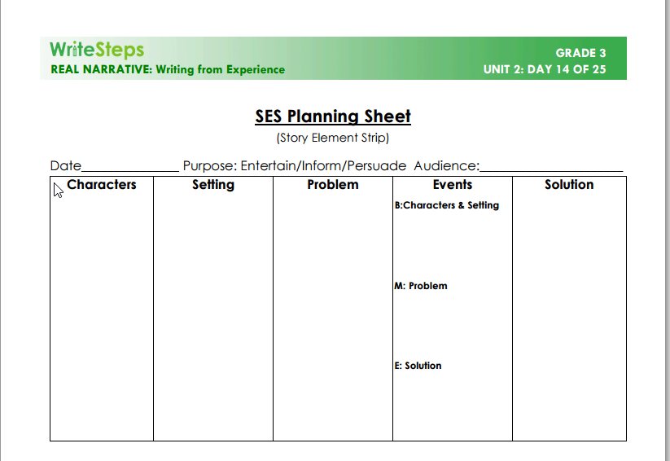
Writing: A N V Adv P N P adj N
Example: The snow piled up in front of my house. (9 yrs. Old)

Example of PE Log:
Activity | Time | Reflection
Built a snowman | 25 min. | My heart was racing because I ran all over the yard and had to roll up a big heavy snowball to make the parts of my snowman.

